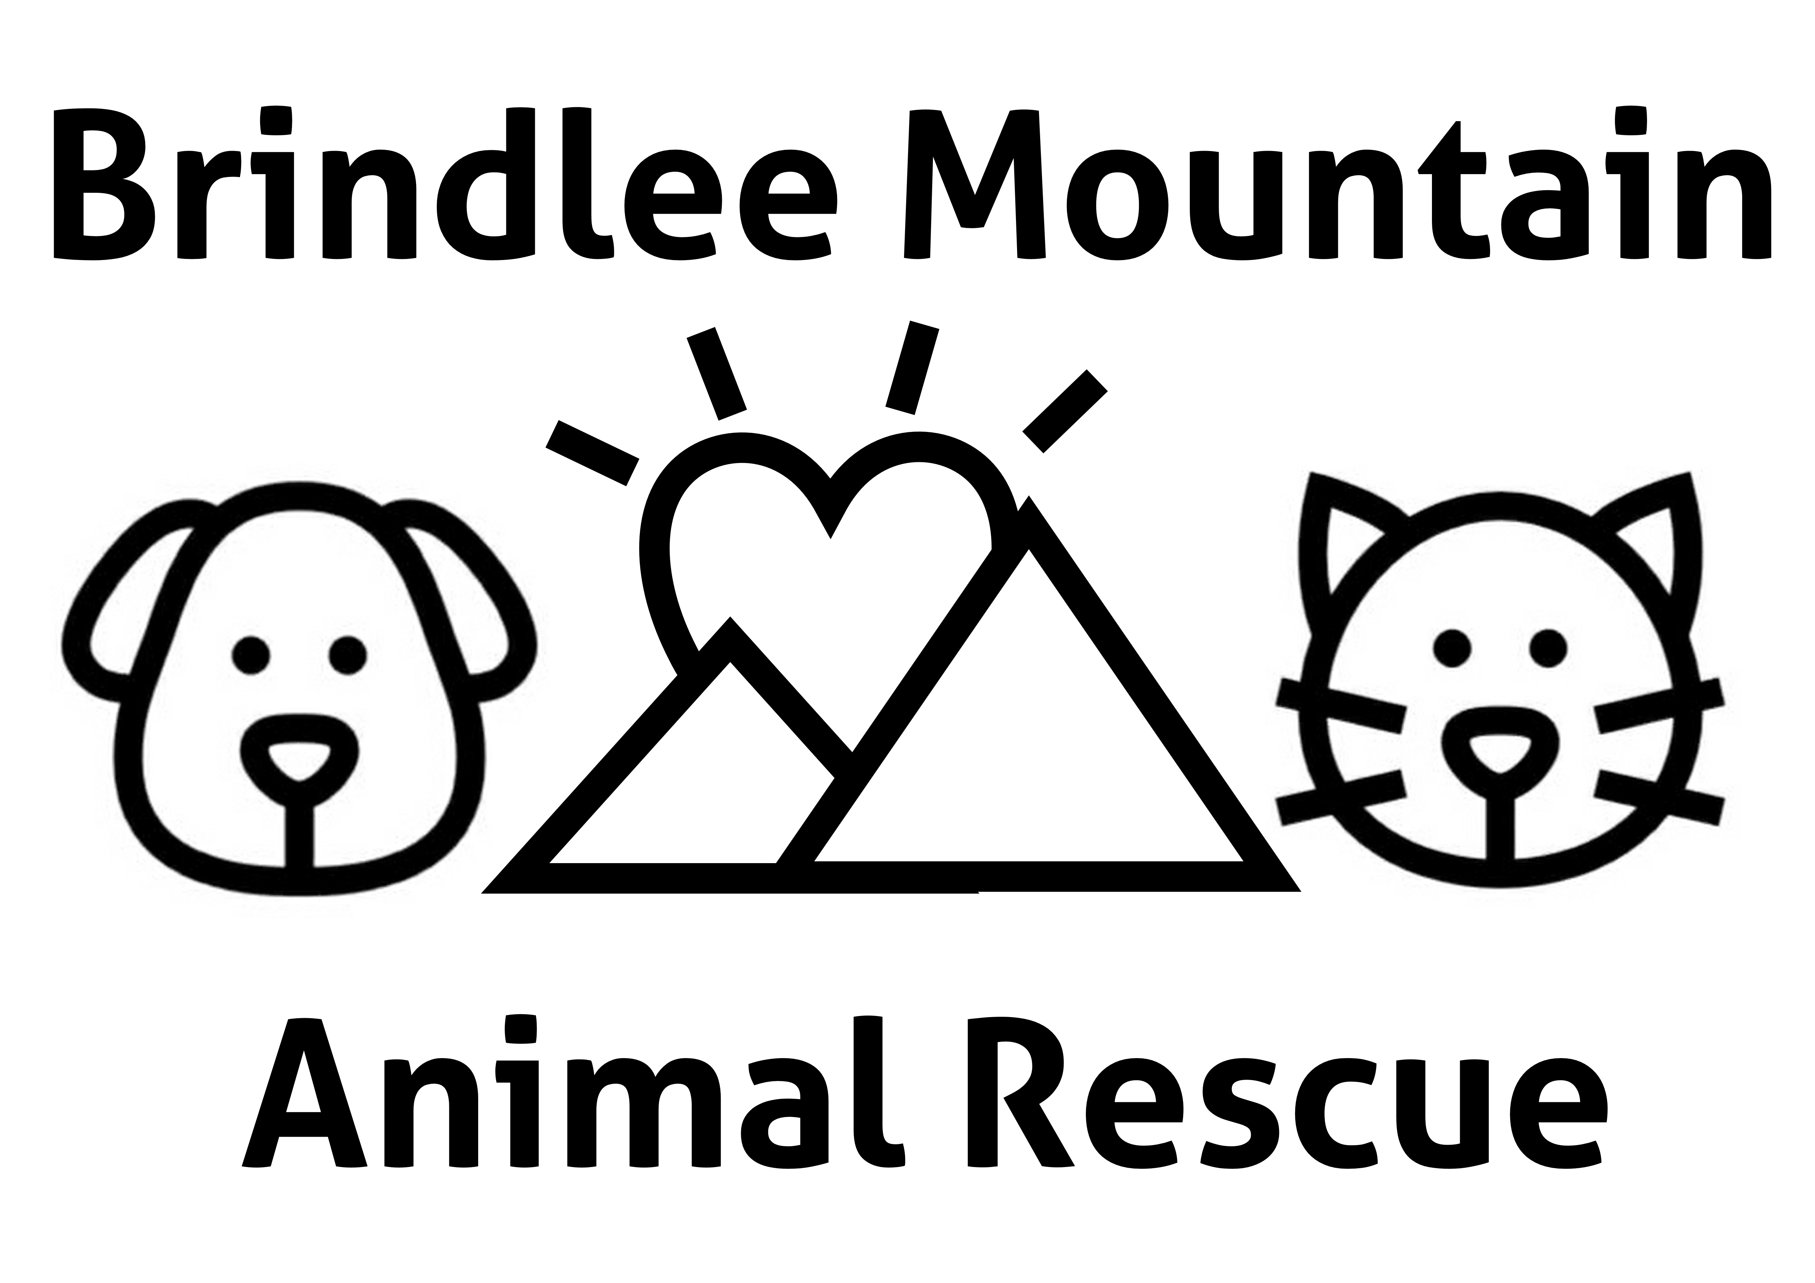
SPAY IT FORWARD
APPLICATION FOR SPAY/NEUTER ASSISTANCE

Name: ______________________________________ Date: ____________________________

Address including city and zip code: _______________________________________________

Phone Number: __________________ E-mail address: _________________________________

Species of pet: _____ dog _____ cat _______ other: identify ________________________

Age of your pet: _____________ Weight of your pet: __________________

Does your pet have any known health conditions? If so, list them here: ____________________
______________________________________________________________________________

When did your pet last see a veterinarian? ___________________________

Do you currently have a veterinarian? _____ yes _______ no

If so, name of veterinarian: ___________________________

Please tell us why you feel you qualify for assistance or tell us any special circumstances you feel we should know about. All information is kept strictly confidential.
______________________________________________________________________________________________________________________________________________________________________________________________________________________________________________________________________________________________________________________________________________________________________________________________________

Please understand that we are a non-profit organization whose volunteers work extremely hard to raise funds to subsidize spay-neuters. We get many requests for assistance and we make every effort to help as many people as possible. Because funds are always limited, we cannot guarantee that we will be able to help you. Your contribution is vital.

11. How much can you contribute to the spay/neuter? ________________

I acknowledge that I will be required to complete this form fully and then contact Brindlee Mountain Animal Rescue, Inc. by email or by telephone to request a counseling session regarding my request for assistance. I also understand that any assistance provided to me is limited to having my pet spayed or neutered.

______________________________________
Signature

Brindleemountainanimalrescue@gmail.com 256-200-2094

